**Circuitos de puertas lógica**

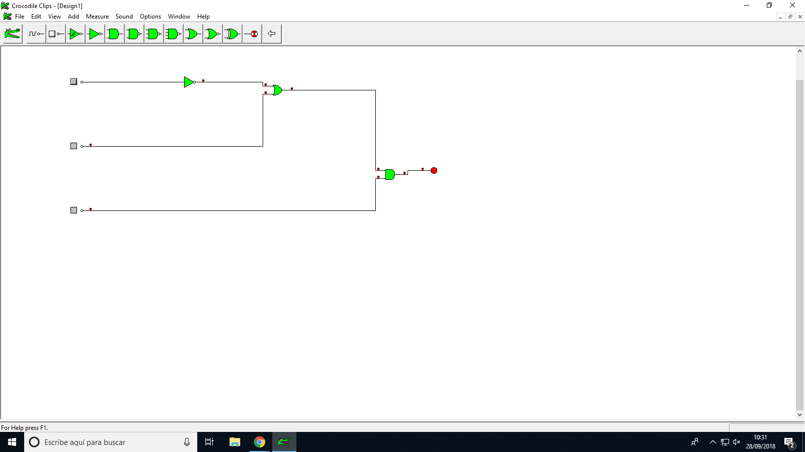

**A B C SALIDA**

|  |  |  |  |
| --- | --- | --- | --- |
| 0 | 0 | 0 | 0 |
| 0 | 0 | 1 | 1 |
| 0 | 1 | 0 | 0 |
| 0 | 1 | 1 | 1 |
| 1 | 0 | 0 | 0 |
| 1 | 0 | 1 | 0 |
| 1 | 1 | 0 | 0 |
| 1 | 1 | 1 | 1 |

**SALIDAS:**

Salida= (á+b).c

Salidas= á.´b.c + a.b.c + á.b.c